# FERTILIZERS RECOMMMENDATION FOR DISEASE PREDICTION

**IBM PROJECT REPORT**

SUBMITTED BY

**TEAM ID:PNT2022TMID14717**

**TEAM MEMBERS:**

RASIKA M

SANJANA K

THARANI G

DEVADHARSHINI S

|  |  |  |
| --- | --- | --- |
| **S.NO** | **TABLE OF CONTENTS** | **PAGE NO** |

|  |  |  |
| --- | --- | --- |
| 1 | **PROJECT OVERVIEW** | **3** |
| 2 | **PURPOSE** | **4** |
| 3 | **LITERATURE SURVEY** | **5** |
| 4 | **REFERENCE** | **6** |
| 5 | **PROBLEM STATEMENT** | **9** |
| 6 | **IDEATION AND PROPOSED SOLUTION** | **10** |
| 7 | **BRAINSTROMING** | **11** |
| 8 | **EMPATHY MAP** | **13** |
| 9 | **PROPOSED SOLUTION FIT** | **14** |
| 10 | **REQUIRED ANALYSIS** | **17** |
| 11 | **PROJECT DESIGN** | **19** |
| 12 | **PROJECT SCHEDULE** | **24** |
| 13 | **CODING AND SOLUTION** | **28** |
| 14 | **TESTING RESULTING** | **30** |
| 15 | **ADVANTAGES** | **34** |
| 16 | **DISADVANTAGES** | **34** |
| 17 | **CONCLUSION** | **34** |
| 18 | **FUTURE SCOPE** | **35** |

1. **INTRODUCTION**

### PROJECT OVERVIEW

Agriculture is the most important sector in today’s life. Most plants are affected by

a wide variety of bacterial and fungal diseases . Plant diseases cause yield reductions that have a direct influence on the domestic and international food production systems and lead to financial losses. The Food and Agriculture Organization of the United Nations International Plant Protection Convention (2017) estimates that plant diseases and pests cause a 20% to 40% loss in worldwide food production. An estimated 13% of the global crop yield loss is attributable to plant diseases. These figures demonstrate how crucial it is to recognize plant diseases in order to reduce production losses. But first, it's essential to comprehend the causes of plant illnesses. Three factors aid disease formation in plants: the host, a favorable environment, and the pathogen. In most cases, diseases begin to show symptoms and affect the plant from the bottom up. The triangle of plant disease is formed by these elements. Plant pathologists can most easily detect foliar diseases, or plant diseases that manifest symptoms on leaves, by looking at these diseases distinctive characteristics. Up to 50% of yield losses are specifically attributable to fungal infections.

HOST



DISEASE

PATHOGEN ENVIRONMENT

Therefore, the majority of contemporary studies employ computer vision, machine learning and deep learning methods to recognize illnesses in photos of plant leaves. The severity of corn streak disease was also quantified using image processing techniques, and it was shown that computer based approaches were more precise than conventional visual examination. Developed Technologies have provided the ability to produce sufficient food to meet the demand of society. The food's and the crops' safety and security, however, remained unachieved. Farmers face difficulties due to factors such as climate change, a decrease in pollinators, plant diseases, and other issues. These qualities require a strong foundation, which needs to be accomplished as soon as possible. The utilisation of analysis and detection techniques employing current technology aids farmers in solving such issues. The country depends on modern technologies in pandemic scenarios like COVID 19 to handle problems and stop the spread of the diseases. Because they can cause famines and droughts, plant diseases pose a serious threat to human survival.

## PURPOSE

Agriculture provides food to all the human beings even in case of rapid increase in the

population. It is recommended to predict the plant diseases at their early stage in the field of agriculture is essential to cater the food to the overall population. But it is unfortunate to predict the diseases at the early stage of the crops. The idea behind the project is to bring awareness amongst the farmers about the cutting-edge technologies to reduce diseases in plant leaf. Several factors associated with disease diagnosis in plants using deep learning techniques must be considered to develop a robust system for accurate disease management. However, despite the range of applications, several gaps within plant disease research are yet to be addressed to support disease management on farms. Thus, there is a need to establish a knowledge base of existing applications and identify the challenges and opportunities to help advance the development of tools that address farmers’ needs.

The aim of our project is to identify

* what disease does our crop have,
* what is the cause of disease
* how to prevent the disease
* how to cure the disease
* fertilizer recommendation to cure the disease

## LITERATURE SURVEY

### EXISTING PROBLEM

1. This method used datasets to find diseased and healthy plant leaves. we introduced a deep convolutional neural network to identify crop series and diseases that may not be present in the plant tissue. The model trained on the test set has an accuracy of 99.35%. This process is enabled by deep learning, machine learning and digital epidemiology. A neural network associates images of diseased plants and crops as a pair. A neural network node is a mathematical function that receives numerical inputs from input edges and provides numerical outputs as output edges. We analyze 54,306 images of plant leaves that have been assigned a variance of 38 class labels. We resize the images to 256x256 pixels and perform both model optimization and prediction on these reduced images.
2. This system explains about Plant identification system developed by computer vision researchers to know plant diseases. In this article, A network (CNN) can be used to gain an intuition of selected features based on a deconvolution network (DN) approach. Different order of veins is the best representative feature. We observe a multi-level representation of leaf data compared to that of contour shapes, showing hierarchical transformation of features. From a lower abstraction to a higher abstraction corresponding to the seed class. These insights gave us insight into the design of new hybrid feature extraction models that can continue to improve.

The uniqueness of the plant classification system.

1. This explains about the several ways to recognize plant medical condition. Some diseases have no visible symptoms, or takes effect too late to act, and Advanced analytics require Changes in symptoms exhibited by diseased plants. Evaluate the performance of the detection algorithm. To distinguish between diseased and healthy leaves, another class was added to the dataset. The source was removed using a developed Python script comparison procedure.
2. This proposed system explains about the water needs of plants vary from place to place due to changes in soil content, texture, climatic factors, and more. In addition to water requirements, plant diseases can also cause plants not to grow properly. In this article, we proposed a new intelligent irrigation system that can automatically control irrigation using an Android mobile application. In addition, photos of plant leaves are captured and sent to the cloud server. This is further processed and compared with images of diseased plant leaves in the cloud database. Based on the comparison, a list of suspected plant diseases is displayed to the user via an Android mobile application.
3. The proposed method makes use of soil and PH samples as input and helps predict plants that can be recommended for soil and fertilizer that can be suitable. Information on the ground is collected by sensors and the data is transmitted from the Arduino via Zigbee and WSN (Wireless Sensor Network) to MATLAB. Analysis and processing of soil data are performed using ANN (Artificial Neural Neural Networks) and crop recommendations are carried out using SVMs (Support Vector Machines).

[6] This paper presents a methodology for classifying three major leaf diseases of banana using local textural characteristics. Disease-affected regions are identified using image enhancement and color segmentation. The segmented image is transformed into one transform domain using three Image transforms (DWT, DTCWT, and ranklet transforms). Feature vectors are extracted from transform-domain images using LBP and its variants (ELBP, MeanELBP, and MedianELBP). Experimental results showed the best classification performance of ELBP features extracted from the DTCWT domain (accuracy 95.4%, accuracy 93.2%, sensitivity 93.0%, Fscore 93.0%, and specificity 96.4%).

### REFERENCES

#### Using Deep Learning for Image-Based Plant Disease Detection

S. Sankaran, A. Mishra, R. Ehsani, and C. Davis, “A review of advanced techniques for detecting plant diseases,” Computers and Electronics in Agriculture.

#### How Deep Learning Extracts and Learns Leaf Features for Plant Classification

Sue Han Leea, Chee Seng Chan, corresponding authora, Simon Joseph Mayob, Paolo Remagninoc.

#### Deep Neural Networks Based Recognition of Plant Diseases by Leaf ImageClassification

Srdjan Sladojevic , 1 Marko Arsenovic, Andras Anderla, Dubravko Culibrk , and Darko Stefanovic. Department of Industrial Engineering and Management , Faculty of Technical Sciences University of Novi Sad , Trg Dositeja Obradovica 6 , 21000 Novi Sad, Serbia .

#### Using Deep Learning for Image-Based Plant Disease Detection

S. Sankaran, A. Mishra, R. Ehsani, and C. Davis, “A review of advanced techniques for detecting plant diseases,” Computers and Electronics in Agriculture.

#### How Deep Learning Extracts and Learns Leaf Features for Plant Classification

Sue Han Leea, Chee Seng Chan, corresponding authora, Simon Joseph Mayob, Paolo Remagninoc.

#### Deep Neural Networks Based Recognition of Plant Diseases by Leaf ImageClassification

Srdjan Sladojevic , 1 Marko Arsenovic, Andras Anderla, Dubravko Culibrk , and Darko Stefanovic. Department of Industrial Engineering and Management , Faculty of Technical Sciences University of Novi Sad , Trg Dositeja Obradovica 6 , 21000 Novi Sad, Serbia .

#### Cloud based automated irrigation and plant leaf disease detection system using an android application

O. T. Zaheema ,Department of Computer Science Engineering, Eranad Knowlededge City Technical Campus, Manjeri, Kerala, India

#### Agro based crop and fertilizer recommendation system using machine learning

Preethi G , Rathi Priya V , Sanjula S M ,Lalitha S D , Vijaya Bindhu B. Final Year CSE,

R.M.K Engineering College , [rath16309.cs@rmkec.ac.in](mailto:rath16309.cs@rmkec.ac.in) , Assistant Professor , R.M.K. Engineering College , [sdi.cse@rmkec.ac.in](mailto:sdi.cse@rmkec.ac.in) , Cognizant Technology Solutions - 2020.

#### Foliar fungal disease classification in banana plants using elliptical local binary pattern on multiresolution dual tree complex wavelet transform domain

Deepthy Mathew, C. Sathish Kumar, K. Anita Cherian. Department of Electronics and Communication Engineering , Rajiv Gandhi Institute of Technology , APJ Abdul Kalam Technological University, Kottayam 686501, India . Department of Electronics and Communication Engineering , Government Engineering College, Idukki 685603, India . Department of Plant Pathology , College of Horticulture , Kerala Agricultural University, Thrissur 680656, India-2020.

#### An automated segmentation and classification model for banana leaf disease detection

V. Gokula Krishnan1 , J. Deepa , Pinagadi Venkateswara Rao , V. Divya , S. Kaviarasan.Associate Professor , CSIT Department , CVR College of Engineering , Hyderabad , India.Assistant Professor , CSE Department , EaswariEngineering College , Chennai ,India- 2022.

**PROBLEM STATEMENT DEFINITION**

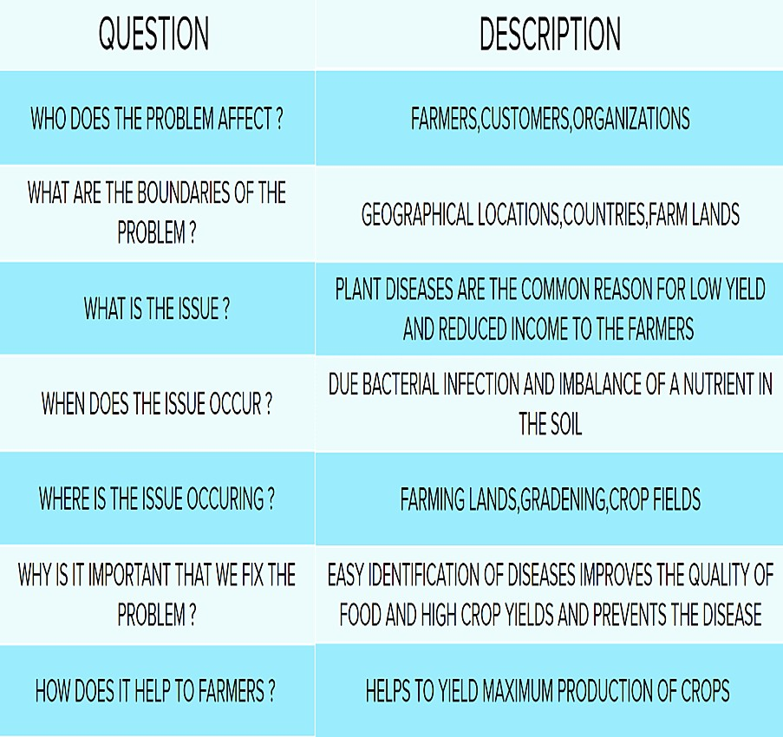

1. **IDEATION & PROPOSED SOLUTION**

### EMPATHY MAP

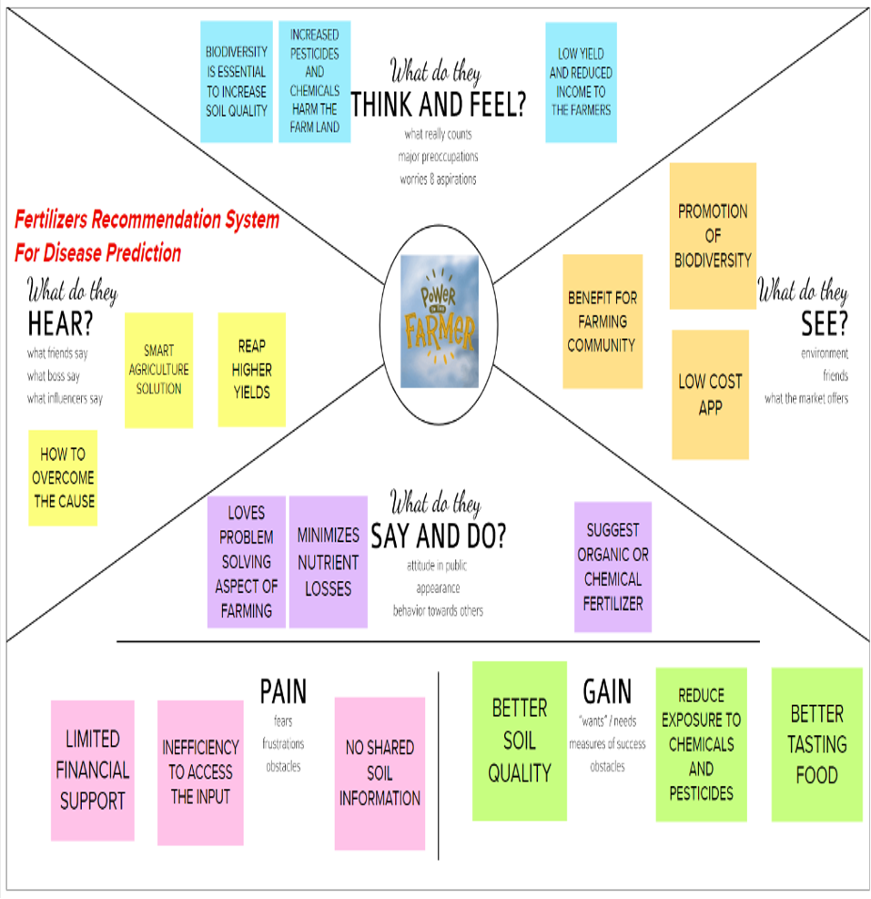

* 1. **IDEATION AND BRAINSTROMING**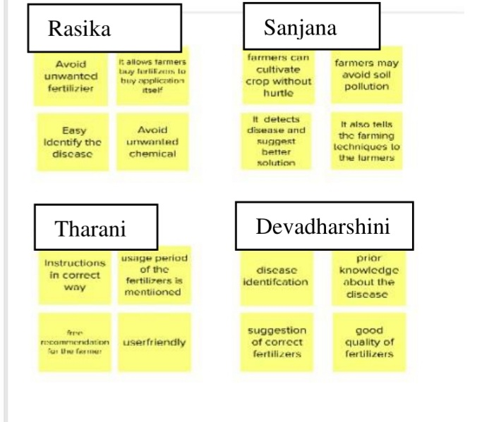

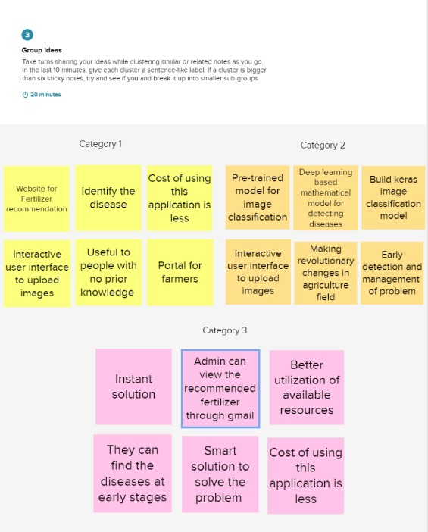

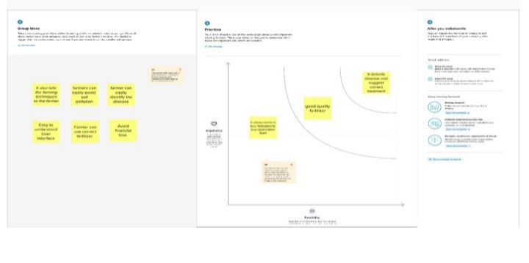

### PROPOSED SOLUTION

|  |  |  |
| --- | --- | --- |
| **S.No.** | **Parameter** | **Description** |
| 1. | Problem Statement (Problem to be solved) | The Covid19 pandemic has already had a damaging effect on agriculture and allied sectors across the globe. While local ecosystems have encountered severe disruption, global supply chains have completely crashed. The crisis will soon pass but one of its most critical impacts will be – firstly, faster adoption of digital technologies and secondly, increased mechanization across the value chains. This is where data science combined with artificial intelligence and machine learning (AI/ML) will come increasingly into play.  The whole concept of smart farming, which is making agriculture more efficient and sustainable, and thus profitable, is largely driven by AI/ML technologies. These technologies can be used in crop and water management, pest and disease detection, crop health monitoring and yield estimation, cultivating and harvesting by smart tractors without drivers as well as other types of forecasts and predictive analytics. |
| 2. | Idea / Solution description | A key application of AI has been helping in identifying pests and diseases. Custom databases for specific crops and helps farmers identify pests and plant diseases with nothing but just a mobile phone. This saves human intervention, cost of hiring an expert and, most importantly, there is no delay in diagnosis.  Sensors are also being used to detect and target weeds. In some instances, robots are used to uproot weeds and in others, it helps in targeted application of pesticides. One research team that used AI technology to detect disease in cassava plants in Tanzania found that AI was able to detect disease with 98 percent accuracy. Instead of spraying pesticides uniformly over the entire cropping area which is an expensive proposition for the farmer, ML can aid in targeting the inputs precisely in terms of time, place and affected plants. This can reduce the chemicals used and improve the quality of produce, and save cost. |
| 3. | Novelty / Uniqueness | This application can advise good fertilizer for diseases in the plant by recognizing the images |
| 4. | Social Impact / Customer Satisfaction | Consumers Farming is one of the major sectors that influences a country’s economic growth. In country like India, majority of the population is dependent on agriculture for their livelihood. Many new technologies, suchas Machine Learning and Deep Learning, are being implemented into agriculture so that it is easier for farmers to grow and maximize their yield. |
| 5. | Business Model (Revenue Model) | The application is recommended based on farmers necessity |
| 6. | Scalability of the Solution | This application might be improved by introducing online purchases of crops fertilizers seamlessly |

* 1. **PROBLEM SOLUTION FIT**

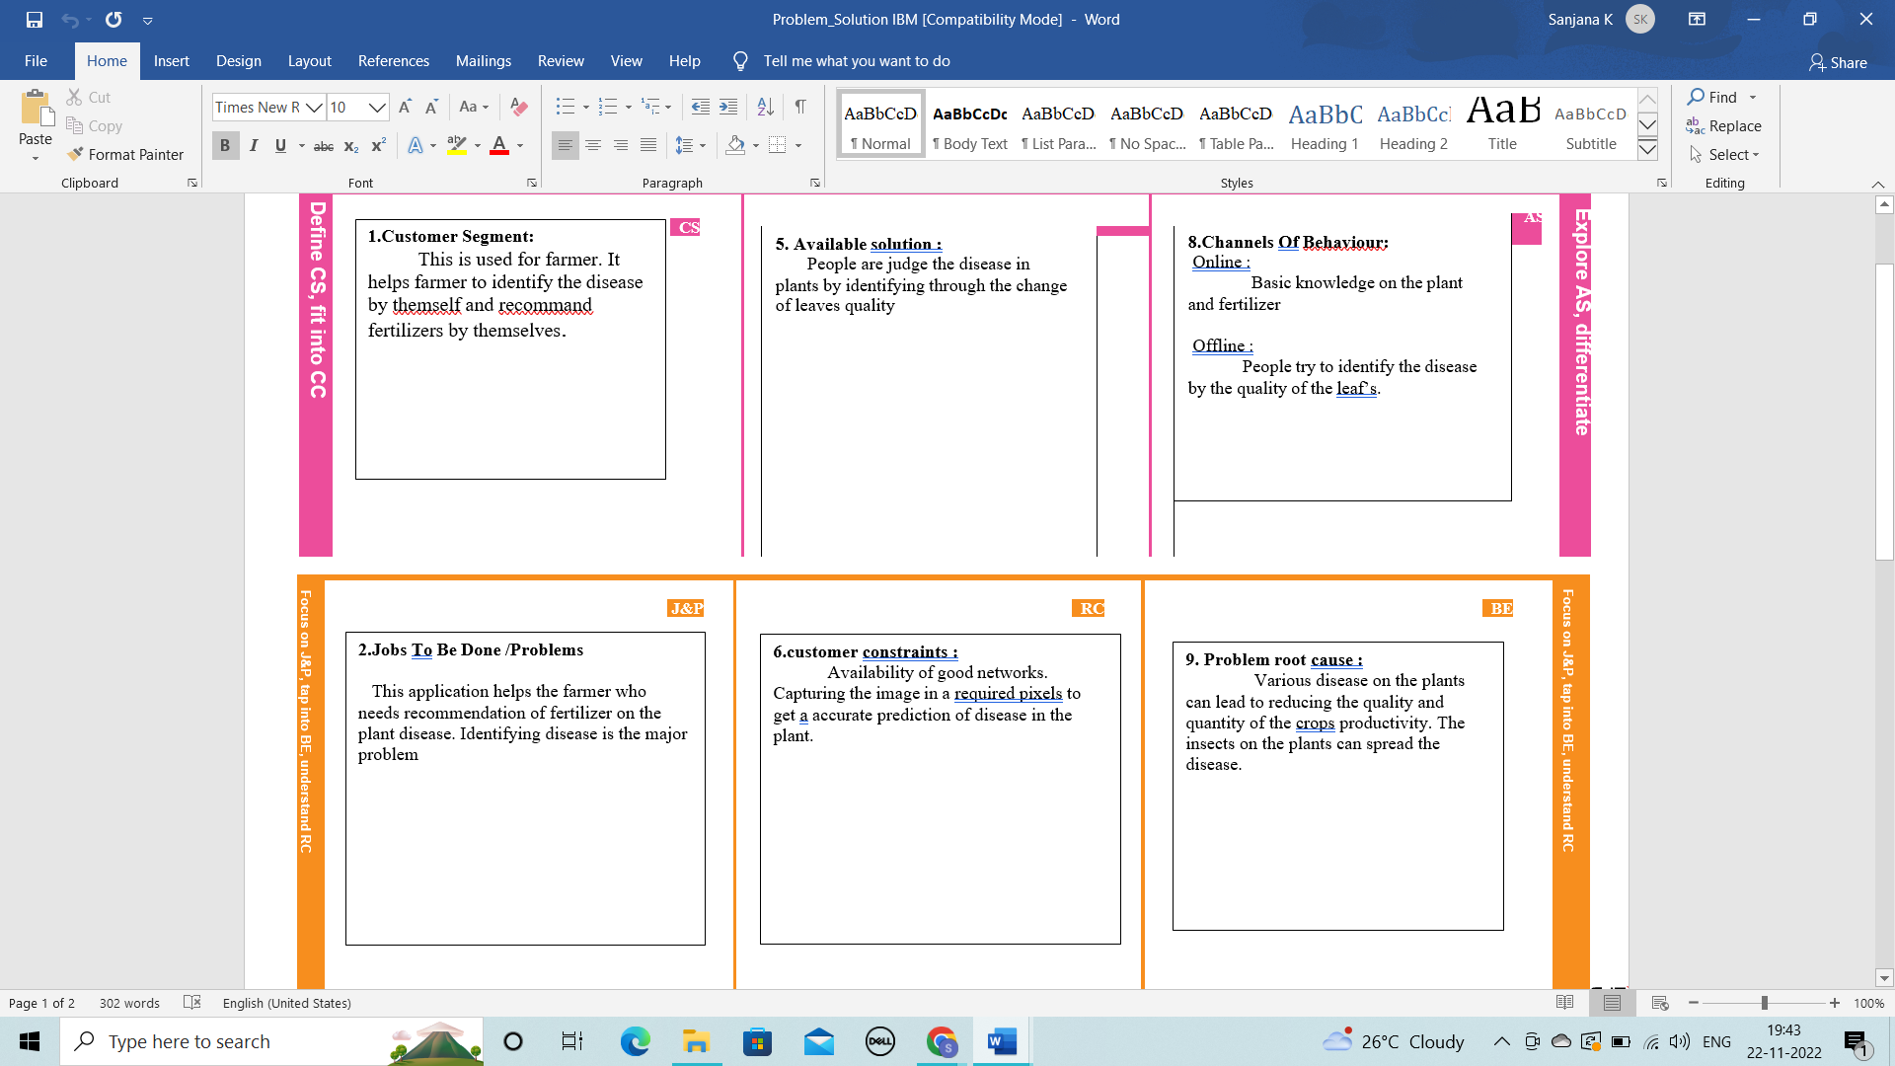



## REQUIREMENT ANALYSIS

### FUNCTIONAL REQUIREMENT

Following are the functional requirements of the proposed solution.

|  |  |  |
| --- | --- | --- |
| **FR No.** | **Functional Requirement** | **Sub Requirement** |
| Fr-1 | User registration | Registration through form Registration through Gmail |
| Fr-2 | User confirmation | Confirmation via OTP  Confirmation via Email |
| Fr-3 | Capturing image | Capture the image of the leaf  and check the parameter of the captured image . |
| Fr-4 | Image processing | Upload the image for the  prediction of the disease in the leaf. |
| Fr-5 | Leaf identification | Identify the leaf and predict the  disease in leaf. |
| Fr-6 | Image description | Suggesting the best fertilizer for  the disease. |

### NON - FUNCTIONAL REQUIREMENTS

Following are the non-functional requirements of the proposed solution.

|  |  |  |
| --- | --- | --- |
| **NFR No.** | **Non-Functional**  **Requirement** | **Description** |
| Nfr-1 | Usability | Datasets of all the leaf is  used to detecting the disease that present in the leaf. |
| Nfr-2 | Security | The information belongs to  the user and leaf are secured highly. |
| Nfr-3 | Reliability | The leaf quality is important  for the predicting the disease in leaf. |
| Nfr-4 | Performance | The performance is based on  the quality of the leaf used for disease prediction |
| Nfr-5 | Availability | It is available for all user to  predict the disease in the plant |
| Nfr-6 | Scalability | Increasing the prediction of  the disease in the leaf |

## PROJECT DESIGN

An automated system is introduced to identify different diseases on plants by checking the symptoms shown on the leaves of the plant. Deep learning techniques are used to identify the diseases and suggest the precautions that can be taken for those diseases.

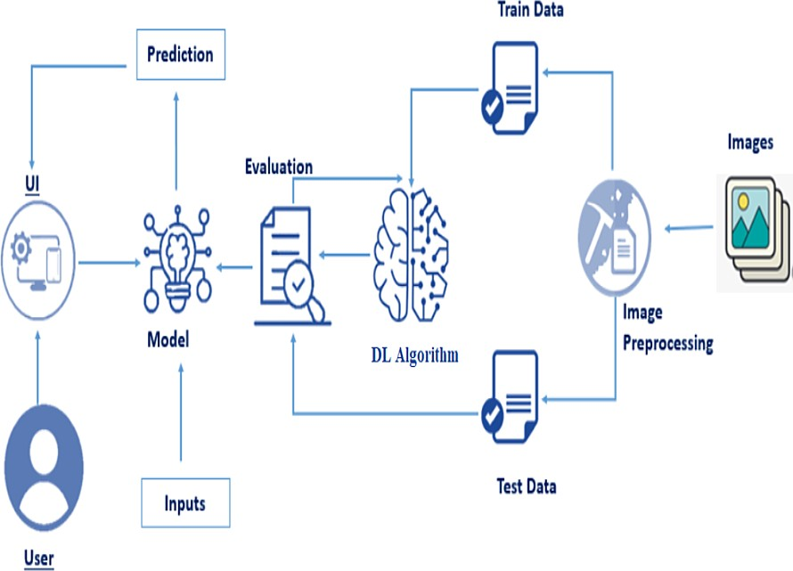

### DATA FLOW DIAGRAMS

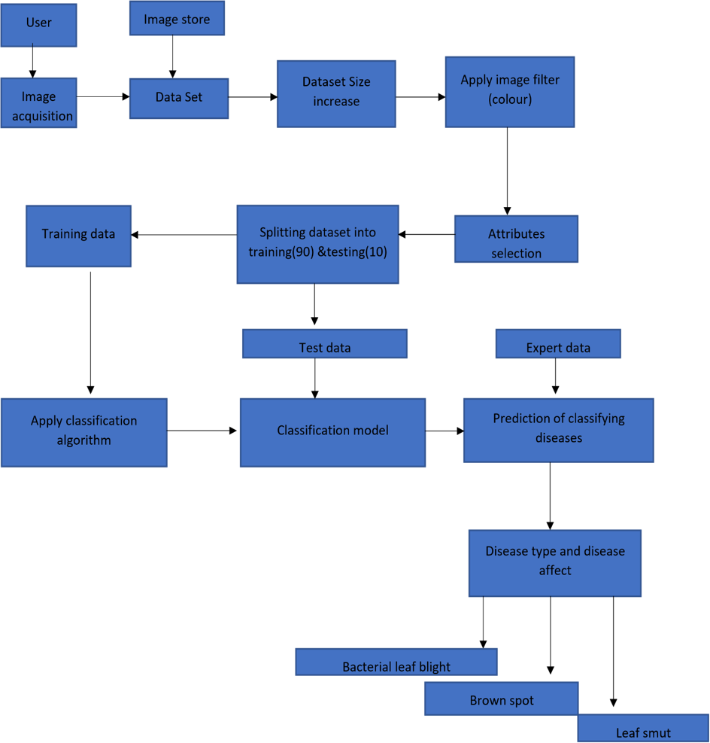

* 1. **SOLUTION & TECHNICAL ARCHITECTURE**

### SOLUTION ARCHITECTURE:

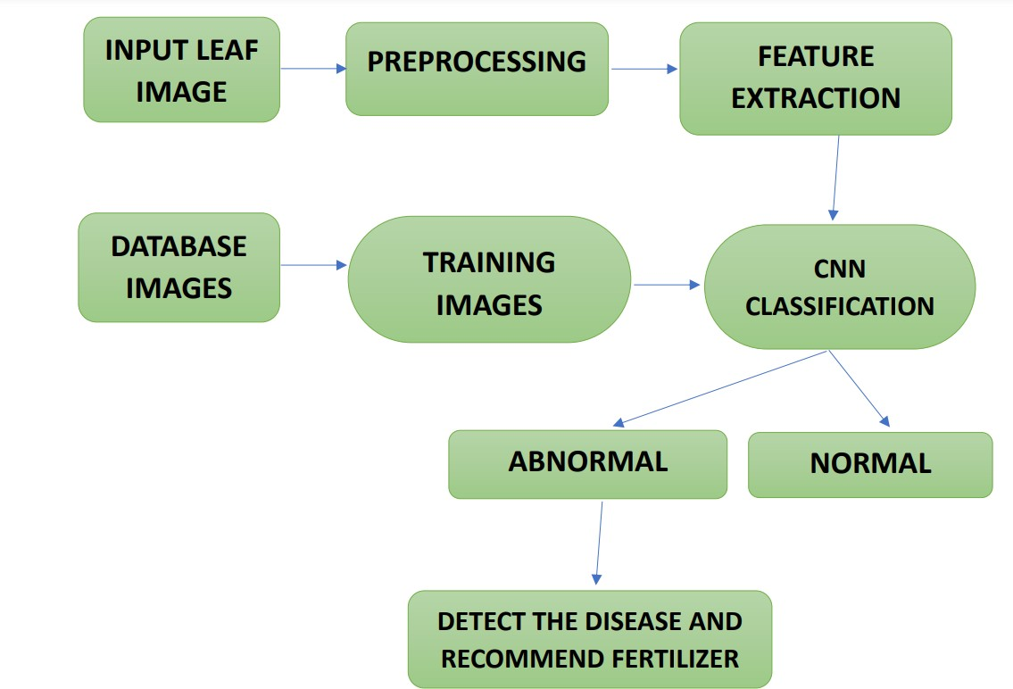

**TECHNICAL ARCHITECTURE:**

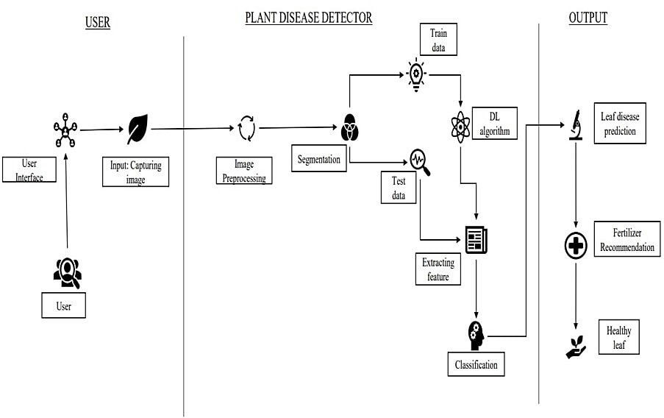

* 1. **USER STORIES**

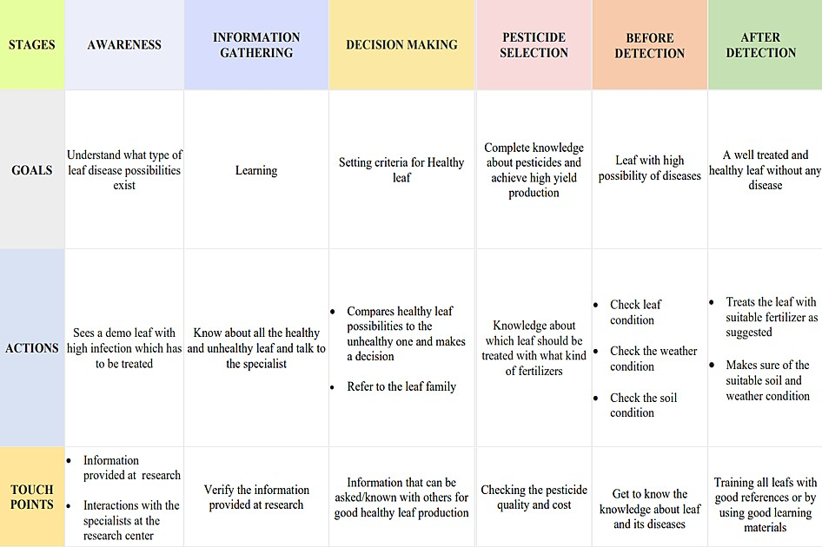

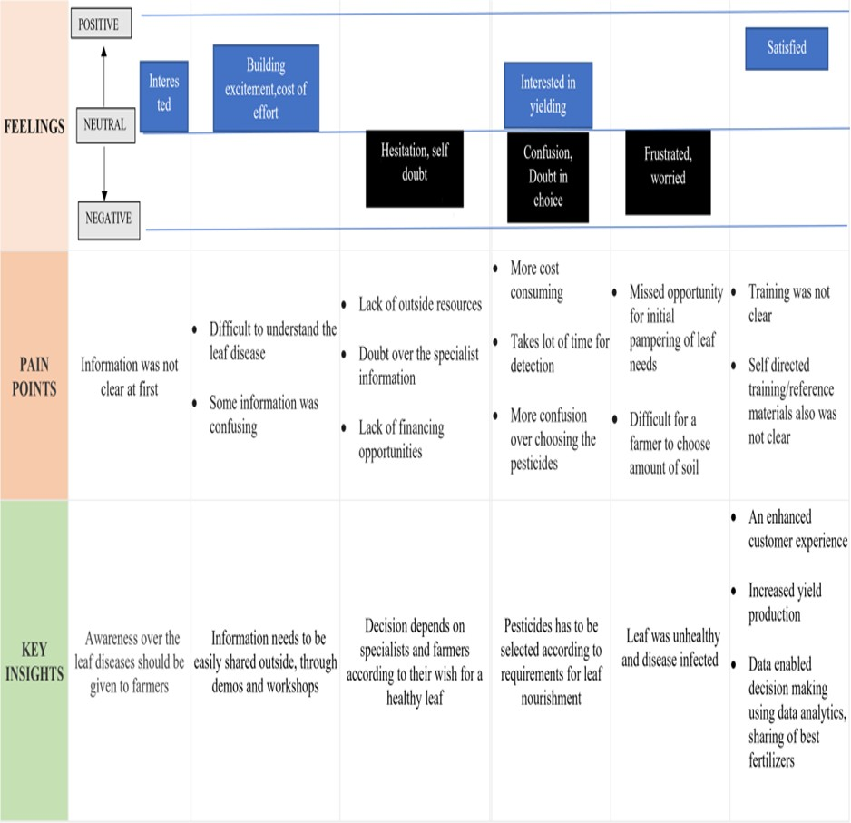

## PROJECT PLANNING & SCHEDULING

### SPRINT PLANNING & ESTIMATION

|  |  |  |  |  |  |  |
| --- | --- | --- | --- | --- | --- | --- |
| **Sprint** | **Functional Requirement**  **(Epic)** | **User Story**  **Number** | **User Story / Task** | **Story Points** | **Priority** | **Team Members** |
| Sprint-1 | Data collection and  preprocessing | USN-1 | Collecting plant disease dataset | 2 | Low | Rasika M Sanjana K |
| Sprint-1 |  | USN-2 | Labelling the dataset according to  class | 3 | Medium | Sanjana K |
| Sprint-1 |  | USN-3 | 38 types of plant  diseases is labeled accordingly | 2 | Medium | Sanjana K |
| Sprint-1 |  | USN-4 | Data set Will contain both healthy and  diseased data | 1 | Low | Sanjana K |
| Sprint-1 | Preprocessing | USN-5 | To prepare raw data in a format that the  network can accept | 2 | High | Sanjana K |
| Sprint-1 |  | USN-7 | Shear range image will be distorted along an axis, mostly to create or rectify the  perception angle | 3 | High | Rasika M  Sanjana K |

|  |  |  |  |  |  |  |
| --- | --- | --- | --- | --- | --- | --- |
| Sprint-1 |  | USN-8 | Zoom  Augmentation will randomly zoom the image and adds new pixels for the image | 3 | High | Rasika M  Tharani G |
| Sprint-1 |  | USN-9 | Flipping the entire  pixels of an image horizontally | 3 | High | Rasika M  Devadharshini S |
| Sprint-2 | Training ,  Testing and Creating a model | USN-10 | Start initiating the  model | 3 | Medium | Tharani G |
| Sprint-2 |  | USN-11 | Adding different  layers of cnn( convolution, pooling dense , flatten ) | 2 | Medium | Tharani G |
| Sprint-2 |  | USN-12 | Creating/compiling  with adam optimizer | 1 | Medium | Tharani G |
| Sprint-2 |  | USN-13 | Keras - Categorical  Cross Entropy Loss Function for multi- class classification | 2 | Medium | Tharani G |
| Sprint-2 |  | USN-14 | creating metrics | 2 | Medium | Sanjana K  Devadharshini S |
| Sprint-2 |  | USN-15 | train the data with  20 epoch | 3 | High | Rasika M  Devadharshini S |
| Sprint-2 |  | USN-16 | testing the model | 5 | High | Tharani G  Sanjana K |

|  |  |  |  |  |  |  |
| --- | --- | --- | --- | --- | --- | --- |
| Sprint-2 |  | USN-17 | save the model | 2 | Medium | Tharani G |
| Sprint-3 | Flask and  Frame workdesign | USN-18 | Creating backend  framework with flask | 8 | High | Rasika M |
| Sprint-3 |  | USN-19 | importing the  model file | 3 | Medium | Rasika M |
| Sprint-3 |  | USN-20 | Create route to link  htmlRoutes and View Functions in Flask Framework index file | 5 | High | Rasika M |
| Sprint-3 |  | USN-21 | Server Startup,  requests and services in a loop | 4 | Medium | Sanjana K  Tharani G  Devadharshini S |
| Sprint-4 | Front end web  application development | USN-22 | creating a html  template with css file | 8 | High | Devadharshini S |
| Sprint-4 |  | USN-23 | user can import  diseased plant leaf in web page | 2 | Medium | Devadharshini S |
| Sprint-4 |  | USN-24 | predicting what is  the type of disease occurred for the given input | 2 | Medium | Devadharshini S |
| Sprint-4 |  | USN-25 | User can classify as  healthy or diseased | 2 | Medium | Sanjana K  Devadharshini S |
| Sprint-4 |  | USN-26 | if plant has disease  then suggest fertilizer and pesticides | 3 | Medium | Tharani G  Devadharsini S |

|  |  |  |  |  |  |  |
| --- | --- | --- | --- | --- | --- | --- |
| Sprint-4 |  | USN-27 | alert the admin  about the prediction with the gmail | 3 | Medium | Rasika M  Devadharshini S |

* 1. **SPRINT DELIVERY SCHEDULE**

|  |  |  |  |  |  |  |
| --- | --- | --- | --- | --- | --- | --- |
| **Sprint** | **Total Story Points** | **Duration** | **Sprint Start Date** | **Sprint End Date (Planned)** | **Story Points Completed (as on Planned End**  **Date)** | **Sprint Release Date (Actual)** |
| Sprint-1 | 20 | 6 Days | 24 Oct 2022 | 29 Oct 2022 | 20 | 27 Oct 2022 |
| Sprint-2 | 20 | 6 Days | 31 Oct 2022 | 05 Nov 2022 | 20 | 3 Nov 2022 |
| Sprint-3 | 20 | 6 Days | 07Nov  2022 | 12 Nov 2022 | 20 | 10 Nov 2022 |
| Sprint-4 | 20 | 6 Days | 14Nov 2022 | 19 Nov 2022 | 20 | 17 nov 2022 |

## CODING & SOLUTIONING

### FEATURE 1 DATASET

Two datasets will be used, we will be creating two models one to detect vegetable leaf diseases like tomato, potato, and pepper plants and the second model would be for fruits diseases like corn, peach, and apple.

### IMAGE PREPROCESSING

Before training the model, you have to pre-process the images and then feed them on to the model for training. We make use of Keras ImageDataGenerator class for image pre-processing.

Image Pre-processing includes the following main tasks

* Import ImageDataGenerator Library.
* Configure ImageDataGenerator Class.
* Applying ImageDataGenerator functionality to the trainset and test set.

Image data augmentation is a technique that can be used to artificially expand the size of a training dataset by creating modified versions of images in the dataset.

The Keras deep learning neural network library provides the capability to fit models using image data augmentation via the ImageDataGenerator class.

There are five main types of data augmentation techniques for image data; specifically:

* Image shifts via the width_shift_range and height_shift_range arguments.
* The image flips via the horizontal_flip and vertical_flip arguments.
* The image rotates via the rotation_range argument
* Image brightness via the brightness_range argument.
* The image zooms via the zoom_range argument.

An instance of the ImageDataGenerator class can be constructed for train and test.

### Image agumentation

**from** keras.preprocessing.image **import** ImageDataGenerator

train_datagen = ImageDataGenerator(rescale **=** 1.**/**255, shear_range **=** 0.2,zoom_range **=**

0.2,horizontal_flip **=True**)

test_datagen **=** ImageDataGenerator(rescale **=** 1)

x_train=train_datagen.flow_from_directory('/content/drive/MyDrive/fruit-dataset/fruit- dataset/train',batch_size**=**32,target_size**=**(128,128),color_mode**=**'rgb',class_mode**=**'categorical')

x_test=test_datagen.flow_from_directory('/content/drive/MyDrive/fruit-dataset/fruit- dataset/test',batch_size**=**32,target_size**=**(128,128),color_mode='rgb',class_mode='categorical ')

### OUTPUT:

Found 5384 images belonging to 6 classes. Found 1686 images belonging to 6 classes.

## MODEL BUILDING FOR FRUIT DISEASE PREDICTION

**from** tensorflow.keras.preprocessing.image **import** ImageDataGenerator

train_datagen**=**ImageDataGenerator(rescale**=**1.**/**255,zoom_range**=**0.2,horizontal_flip**=True**,vertical_flip**=False**)

test_datagen**=**ImageDataGenerator(rescale**=**1.**/**255)

ls

x_train**=**train_datagen**.**flow_from_directory(r"C:\Users\Person\Desktop\FILES\data_for_ibm\Fertilizers_Recommendation_ System_For_Disease_ Prediction\Dataset Plant Disease\fruit-dataset\fruit-dataset\train",target_size**=**(128,128),

class_mode**=**'categorical',batch_size**=**24)

x_test**=**test_datagen**.**flow_from_directory(r"C:\Users\Praveen\Desktop\FILES\data_for_ibm\Fertilizers_Recommendation_ System_For_Disease_ Prediction\Dataset Plant Disease\fruit-dataset\fruit-dataset\test",target_size**=**(128,128),

class_mode**=**'categorical',batch_size**=**24)

**from** tensorflow.keras.models **import** Sequential

**from** tensorflow.keras.layers **import** Dense,Convolution2D,MaxPooling2D,Flatten

model**=**Sequential()

model**.**add(Convolution2D(32,(3,3),input_shape**=**(128,128,3),activation**=**'relu'))

model**.**add(MaxPooling2D(pool_size**=**(2,2)))

model**.**add(Flatten())

model**.**summary()

32**\***(3**\***3**\***3**+**1)

model**.**add(Dense(300,activation**=**'relu'))

model**.**add(Dense(150,activation**=**'relu'))

model**.**add(Dense(6,activation**=**'softmax'))

model**.**compile(loss**=**'categorical_crossentropy',optimizer**=**'adam',metrics**=**['accuracy'])

len(x_train)

model**.**fit(x_train,steps_per_epoch**=**len(x_train),validation_data**=**x_test,validation_steps**=**len(x_test),epochs**=**10)

model**.**save('fruitdata.h5')

**import** numpy **as** np

**from** tensorflow.keras.models **import** load_model

**from** tensorflow.keras.preprocessing **import** image

model**=**load_model('fruitdata.h5')

img**=**image**.**load_img(r"C:\Users\Person\Desktop\FILES\data_for_ibm\Fertilizers_Recommendation_ System_For_Disease_ Prediction\Dataset Plant Disease\fruit

img**=**image**.**load_img(r"C:\Users\Person\Desktop\FILES\data_for_ibm\Fertilizers_Recommendation_ System_For_Disease_ Prediction\Dataset Plant Disease\fruit-dataset\fruit-dataset\test\Apple___healthy\00fca0da-2db3-481b-b98a-9b67bb7b105c___RS_HL 7708.jpg",target_size**=**(128,128))

img

x**=**image**.**img_to_array(img)

x

x**=**np**.**expand_dims(x,axis**=**0)

x

y**=**np**.**argmax(model**.**predict(x),axis**=**1)

x_train**.**class_indices

index**=**['Apple___Black_rot','Apple___healthy','Corn_(maize)___Northern_Leaf_Blight','Corn_(maize)___healthy','Peach___Bacterial_spot','Peach___healthy']

index[y[0]]

img**=**image**.**load_img(r"C:\Users\Person\Desktop\FILES\data_for_ibm\Fertilizers_Recommendation_ System_For_Disease_ Prediction\Dataset Plant Disease\fruit-dataset\fruit-dataset\test\Apple___healthy\00fca0da-2db3-481b-b98a-9b67bb7b105c___RS_HL 7708.jpg",target_size**=**(128,128))

x**=**image**.**img_to_array(img)

x**=**np**.**expand_dims(x,axis**=**0)

y**=**np**.**argmax(model**.**predict(x),axis**=**1)

index**=**['Apple___Black_rot','Apple___healthy','Corn_(maize)___Northern_Leaf_Blight','Corn_(maize)___healthy','Peach___Bacterial_spot','Peach___healthy']

index[y[0]]

## MODEL BUILDING FOR VEGETABLE DISEASE PREDICTION

**from** tensorflow.keras.preprocessing.image **import** ImageDataGenerator

train_datagen**=**ImageDataGenerator(rescale**=**1.**/**255,zoom_range**=**0.2,horizontal_flip**=True**,vertical_flip**=False**)

test_datagen**=**ImageDataGenerator(rescale**=**1.**/**255)

**from** tensorflow.keras.models **import** Sequential

**from** tensorflow.keras.layers **import** Dense,Convolution2D,MaxPooling2D,Flatten

model**=**Sequential()

model**.**add(Convolution2D(32,(3,3),input_shape**=**(128,128,3),activation**=**'relu'))

model**.**add(MaxPooling2D(pool_size**=**(2,2)))

model**.**add(Flatten())

model**.**add(Dense(300,activation**=**'relu'))

model**.**add(Dense(150,activation**=**'relu'))

model**.**add(Dense(9,activation**=**'softmax'))

model**.**compile(loss**=**'categorical_crossentropy',optimizer**=**'adam',metrics**=**['accuracy'])

len(x_train)

1238**/**24

model**.**fit(x_train,steps_per_epoch**=**len(x_train),validation_data**=**x_test,validation_steps**=**len(x_test),epochs**=**10)

model**.**save('vegetabledata.h5')

**import** numpy **as** np

**from** tensorflow.keras.models **import** load_model

**from** tensorflow.keras.preprocessing **import** image

model**=**load_model('vegetabledata.h5')

img

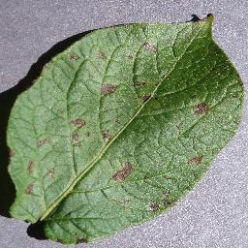

x**=**image**.**img_to_array(img)

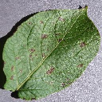

x**=**image**.**img_to_array(img)

x

x**=**np**.**expand_dims(x,axis**=**0)

x

y**=**np**.**argmax(model**.**predict(x),axis**=**1)

x_train**.**class_indices

index**=**['Pepper,_bell___Bacterial_spot','Pepper,_bell___healthy','Potato___Early_blight','Potato___Late_blight','Potato___healthy','Tomato___Bacterial_spot','Tomato___Leaf_Mold','Tomato___Septoria_leaf_spot']

index[y[0]]

x**=**image**.**img_to_array(img)

x**=**np**.**expand_dims(x,axis**=**0)

y**=**np**.**argmax(model**.**predict(x),axis**=**1)

index**=**['Pepper,_bell___Bacterial_spot','Pepper,_bell___healthy','Potato___Early_blight','Potato___Late_blight','Potato___healthy','Tomato___Bacterial_spot','Tomato___Leaf_Mold','Tomato___Septoria_leaf_spot']

index[y[0]]

## ADVANTAGES

The proposed model here produces very high accuracy of classification.

Very large datasets can also be trained and tested.

Images of very high can be resized within the proposed itself.

**DISADVANTAGES**

For training and testing, the proposed model requires very high computational time.

The neural network architecture used in this project work has high complexity

## CONCLUSION

We have proposed ban automated system to identify and classify the disease caused in plants at an earlier stage with pest management.to detect and identification of various diseases, we use the convolutional neural network (CNN) and deep learning. The result from can be used to identify the disease with high accurate and suggest solution . High performance model is obtained by using best hyper parameters and good training data . The final model will give high accuracy for the given data. An application to detect , controls , and monitor the plantdisease helps the farmer to reduce their work as well as time.This application helps the farmer to reduce their effort, and also helps in increasing the farm of production. The proposed method helps to find the plant disease and in monitoring the several environmental conditions the status of the leaf has been identified with the help of neural network classification . Then the environment circumstances such as temperature, humidity and moisture has been monitored the environmental condition is abnormal, then the pump will automatically.This project gives the executed results on different diseases classification techniques that can be used for plant leaf disease detection a. Therefore, related diseases for these plants were taken for identification. With very less computational efforts the optimum results were obtained, which also shows the efficiency of the proposed algorithm in recognition and classification of the leaf diseases. Another advantage of using this method is that the plant diseases can be identified at an early stage or the initial stage. By using this concept, the disease identification is done for all kinds of leafs and also the user can know the affected area of leaf in percentage by identifying the disease properly the user can rectify the problem very easy.

## FUTURE SCOPE

* + This system can be enhanced in future by using the trained model in android apps to make more feasible and efficiently.
  + In future, use of more advanced algorithms can beimplemented into the system to show high accuracy and less process time.
  + Using the camera we canimplement the system in continuous monitoring of crops and plants for detecting the texture of plants for more early detection of plants.
  + After the leaf undergoes detection, the disease is identified and check whether the leaf can be cured at certain conditions or not and fertilizersare recommended according to the leaf.

## GitHub & Project Demo Link

## GitHub Account - <https://github.com/IBM-EPBL/IBM-Project-31200-1660197552>

## Demo Link -

## <https://drive.google.com/file/d/10TYOAIkdp4oEdQQvpwrnEnSIkzX2gtby/view?usp=drivesdk>